14 March 2024

Minutes of the ADCAS meeting on Thursday 07 March 2024
at the Victory Services Club in London

Present

Dave Baldock Chair Grob Group Ltd
Claire Watson Airmatic Ltd z
Tony Warwick Airtrace Sheet Metal Ltd z
Alan Moore BSB Engineering Services Ltd
Mark Fiest Doby Verrolec
Amy Fisher Doby Verrolec
Paul Etty Ductwork by Design Ltd
Chris Yates FETA/ADCAS
Darren Webster Firesafe Fire Rated Ductwork Ltd
Jack Friend Hasman Ltd z
Michael Crane FETA PR Keystone Communications Ltd
Roberto Bernabo Kingspan Insulation Ltd z
Andy Watton Lindab Ltd
Bryan Welch London Ductwork Services T/A RDS
Malcolm Moss Malcolm Moss
Andy Stanford NAADUK z
Oliver Hemingway SIG Trading Limited z
Dan Stride Southern Ductwork (Manufacture) Ltd
Michael Duggan Secretary FETA/ADCAS
z= via Zoom

1 Welcome, apologies and to note the FETA Competition Law Guidelines and Guidelines to FETA committee procedures

If joining remotely members were asked to ensure their name was correctly displayed as we use that for the minutes.

The FETA Competition Law Guidelines and Guidelines to FETA committee procedures to be brought to members attention. The guidelines are available for members to review at https://www.feta.co.uk/members-area/competition-law-and-committee-guidelines. Accepting the invitation, or attending the meeting, will be taken as a member's acknowledgement of the guidelines’ existence.

Members are asked to review the procedures, and particularly the clause on confidentiality of information received at meetings on p3.

2 Minutes of ADCAS meeting on 5 December 2023

The minutes are prepared in accordance with the Guidelines to FETA committee procedures.

2.1 Approval of minutes circulated by email in January and posted on the FETA website
https://www.feta.co.uk/members-area/committee-minutes

The minutes were approved and signed.

2.2 Matters arising

3 Raising the Bar project

Update from the Executive (This project came out of the Raising the bar publication)

- Malcolm Moss has been engaged to manage and lead the project.
- Scope of the project that Executive has approved.
- Deliverable(s) from the project.
- Timings.

CY shared an updated version of the Raising the Bar presentation.

CY will circulate his slides for members, and the content is copied below:

What have we done since the December ADCAS meeting
- Raising the Bar document commissioned in 2020. Author was Paul White.
- Working group set up to review competencies needed for ductwork installers.
- Work undertaken to establish what needs to be done to enable ductwork installers to go on site with a valid CSCS card from 1st January 2025. This is the date personnel need to be deemed ‘competent’.
- Met with the following training providers to establish training and assessment capabilities:
  - The Skill Centre
  - Target Zero
  - Paddeco
  - Choice Training NAADUK – January 2024

Establishment of EBSSA – launched January 2024
The Engineering and Building Services Skills Authority was convened last year by Actuate UK members (of which FETA are one) together with other leading sector bodies, such as BEAMA, CIPHE, TICA and the standards organisation MCS, to provide a credible authoritative voice for skills across engineering and building services.

Key objectives of this skills coalition are to provide analysis based on transparent data on the sector skills demand and supply, and utilise this evidence to highlight needs, educate, influence policy makers and providers to close the skills shortage gaps with measurable interventions.

Underpinning this work is to lead on the development of competences and standards for their disciplines to support the industry transformation towards a safe and healthy built environment and achieving UK’s net zero targets within domestic and non-domestic buildings.

For more information on EBSSA please see: https://www.actuateuk.org.uk/resources/ebssa/

5 super sector forums set up. ADCAS are in engineering services part.

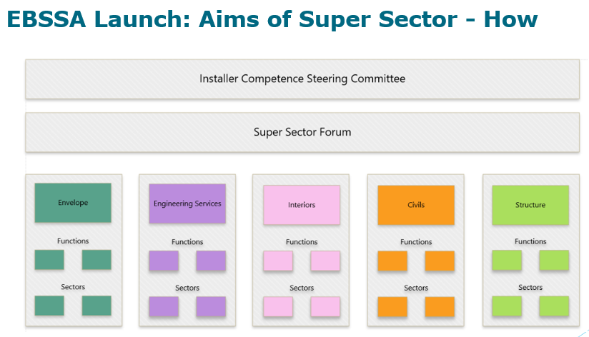

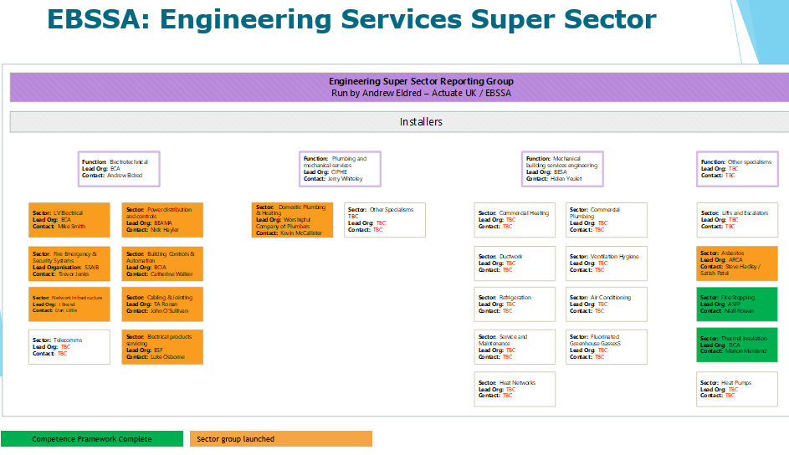

EBSSA and Ductwork

- BESA are driving this and DCAS met with their team to discuss improving the training and assessment for ductwork installers, which has been widened to cover manufacturing as well.
- The work on Ductwork has now been kicked off with the first meeting in February and a further one in April which may help to simplify the training and assessment process.
Key points discussed:
- Ductwork as it was an overdue area for review and we have a relatively blank canvas to work from. The apprenticeships were retired last year, due to lack of support from the industry.
- Kate Milford is on the group as she had done a very successful pilot and is now helping BESA with its approach to competency. L
- Looking at industry-wide schemes to share experience and to raise levels of competency. All looking for skills, knowledge, experience and behaviour.
- We will need to be able to map sectors, occupations, baseline for where we are, identify where we want to be in the future, as well as the pathways that exist and determine if they are fit for purpose. It is therefore a great opportunity to look at the whole rather than the parts.
- Explained that ADCAS was looking for a simple cost-effective way of assessing experience workers as well as raising competency within the industry and had been addressing the area for several years, the driver now being the requirement for CSCS cards to be issued to individuals from 1st January 2025 who are assessed as competent.

Reminder: Key points established

- All offer SVQ training and assessment – NVQ had been withdrawn.
- SVQ recognized by SkillCard and ECS
- Costs vary from £750 to £3000 for training and assessment.
- Assessment is the key point – this gets the card.
- For Experienced Workers the assessment could be a face-to-face meeting or via video to review work the individual has undertaken, understanding of Health & Safety.
- To gain a Blue Card, which is valid for an Experienced Worker from 1st January 2025, the person needs to be enrolled on an SVQ course and have a candidate number. Then has 18 months to complete the assessment.
- We think this is the bare minimum that will be required – being confirmed by meeting with BESA in January 2024

What does this mean for the industry?

- Experienced Workers can start enrolling as of now
- Need to be enrolled by 31 December 2024
- There are a number of training providers ADCAS members can choose from, we are not going to be recommending a provider, just a pathway.
- The training and assessment providers are:
  - NAADUK www.naaduktrainingacademy.co.uk
  - Paddeco www.paddeco.com
  - Target Zero www.targetzerotraining.co.uk
  - The Skill Centre The Skills Centre
- Note: ADCAS believes the SVQ needs extending to cover fire dampers and fire rated ductwork and some of the training and assessment providers do offer this.

Next steps

- Advise ADCAS members again of the current pathways to gaining competency.
- Continue the journey with BESA on competencies

4 Working groups

4.1 Marketing WG and PR update – Claire Watson/Heather Wolfenden

Topics covered are copied below. And more detail in Annex A on proposed website changes and social media

- Website funding:
    - Approval for funding requirements for website enhancements
    - Members can send us updates for their profile on the website
    - Certain sections to be taken down for review
    - New images and usability

- Professional Photoshoot &website images:

    - There is a planned photoshoot at the Manchester meeting
    - Purpose of a photoshoot for social media and website
    - Members send us your images!

- Social Media Channels:

    - Update on LinkedIn presence.
Consider member spotlight to be random not alphabetical.
    - Review of statistics (attached)

- Skills Card Campaign:
    - Explanation of campaign objectives and benefits
    - Aiming to have document ready for approval in May.
    - To include recent installer survey and build UK information signposting

- Membership Pack Review:
    - We are holding a brainstorming session on improving membership pack attractiveness.

- Any Other Business:
  - Open floor for additional topics or concerns
  - Any updates or announcements from members

4.2 Technical WG – Darren Webster

The TWG met in February. They are looking for more members to join the TWG.

EN 15780 – need to modify the ADCAS document to reflect the ADCAS one. Jack Friend volunteered.

Bryan Welch volunteered to review the cleaning document.

MD will send the documents to JF and BW with a comment table for any comments.

The joint one with ASFP can stay as its up to date.

4.3 Training WG – Jack Friend

FETA Training & Skills Group
- Conducted employer survey, survey results reported:
  - 80% of respondents reporting that their business undertakes some sort of formal employee training for existing members of staff.
  - 57% stating that they have considered taking on an apprentice.
  - 32% reporting that they have already taken on an apprentice.
  - 20% of respondents to the skills survey stating they have considered taking a T-Level student on a placement.
- Opportunity of T-Levels and how they can be promoted is an ongoing subject for the group.
- Have been working to comment on the Advanced British Standard issued by Government to reform education for 16-19 years olds. Consultation closes on 20/03/24, anyone can comment and see the consultation DfE consultations on GOV.UK
- Last meeting 13/02/24 – JF apologies
- Next meeting 22/03/34

EBSSA Super Sector
- Initial ductwork competence group meeting held 26/02/24 as part of the 5 Super sectors, of which Engineering & Building Services Skills Authority (EBSSA) is one, created following the work of Working Group 2. First workshop meeting is scheduled for the 18/04/24 to define key objectives. Aim of the group is to raise levels of competence across England, Scotland, Wales and Northern Ireland. Initial view is that 3 key areas we need to cover are:
  - Manufacture
  - Installation
  - Maintenance
b) Update on the FETA Training & Skills Group work – Jack Friend/Chris Yates

CY and JF have attended this. T-Levels are part of it and a survey of members has been carried out. The UK Gov has a consultation out at the moment.

CY and President of BRA met with Jane Hunt MP. She is keen on training. CY will see if she can raise a question in the House.

5 Membership

As at 31st December 2023 the membership was:

Full members: 52
Associate members: 19

New Membership in 2024 Partridge Ventilation Service & Maintenance (Ass)

CY urged members to let us know of any companies they feel we should approach into membership.

There was a discussion on:
- a possible reduced fee to encourage new members, and
- a possible reciprocal arrangement with NAADUK.

6 Finances

ADCAS Account | Income | Expenditure
Balance brought forward as at 01.01.2023 | 78,166
Subscriptions Income 2023 | 56,200
Discounts given |  | 2,200
Build UK Membership |  | 3,990
Meeting Expenses |  | 4,651
Keystone Communications – Raising the Bar work |  | 1,480
P Johnson - Technical Gp work |  | 350
Annual Lunch |  | 481
IT Costs |  | 75
BESA Advert Yr Bk 2022/23 and 2023/24 |  | 2,495
ADCAS Secretariat Fee |  | 30,000
Donation to M Ohley collection |  | 250
Totals | £56,200 | £45,972
Balance as at 31.12.2023 | £88,394

- Secretariat Admin fee paid to FETA in August 2023 was £30,000.
- All membership fees for 2023 have been paid. Payments for 2024 coming in well so far - £56,200 has been invoiced for current membership. Please try and pay promptly.

At the morning meeting, the Executive agreed to fund website development (£2,000) and to pay expenses to MM for the Raising the Bar work.

7 Executive Committee

There is a further one vacancy available on the Executive Committee. Volunteers welcome.

8 News from other organisations

If members have information for this agenda item, I would be pleased to receive any written updates I can include in the minutes of the meeting.

8.1 Build UK - Chris Yates

Weekly briefings are being circulated to members. A meeting on 1st May and CY is looking for volunteers.

8.2 Grenfell Tower Competence Steering Group - Chris Yates

8.3 CIBSE

Hywel Davies, a key staffer at CIBSE, is retiring (from CIBSE) at the end of March. He will continue representing some other organisations on areas he has an interest in.

SPONS guide is being updated. There will be a FETA webinar on this in a month or so.

8.4 ACTUATE UK – Chris Yates

EBSSA work - information on EBSSA is on https://www.actuateuk.org.uk/resources/ebssa/

8.5 Construction Leadership Council - Chris Yates

Product availability is a key topic.

8.6 BESA

Skill cards. FETA has an Indoor Air Quality Group and its open to anyone who wishes to join.

8.7 NAADUK – Nygel Humphrey

Andrew Stanford attended and gave an update.

Membership is growing.

LPCB

BS 15780 review. BW asked if there was any timescale. The portal is open up to 20th March. They are doing it through the BSI procedure. BW said ADCAS should wait until the 2024 published edition of BS 15780 was available before he did a review of the ADCAS cleaning guide as ADCAS has to “react” to whatever requirements are in the BS.

8.8 ASFP

9 Any other business

The FETA annual lunch is fully booked. ADCAS has a table reserved.

Tues 19 March - webinar that will be recorded. If ADCAS wish to do a similar one on competency, CY can arrange it.

9.2 Contractors in the Northwest

Darren Webster said a group of interested parties in the Northwest met and discussed the situation regarding the requirements to renew the CSCS cards for ductwork installers and the NVQ2 qualifications and conducted a survey (results copied below) to see what really is happening. This shows in, Darren’s opinion, a desire to gain qualification but needs to have value and currently this is not seen.

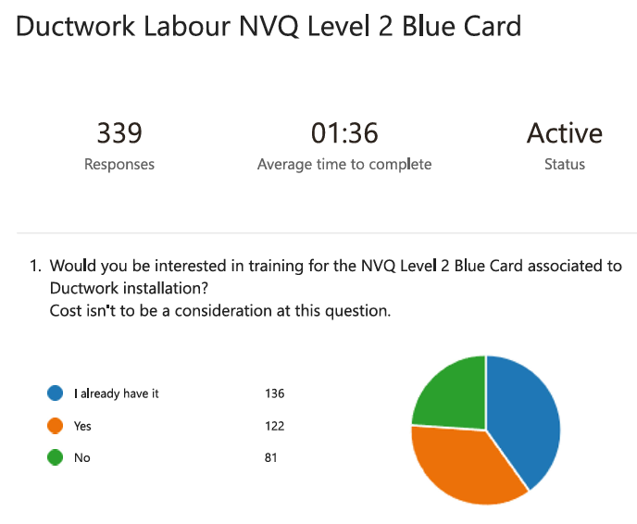
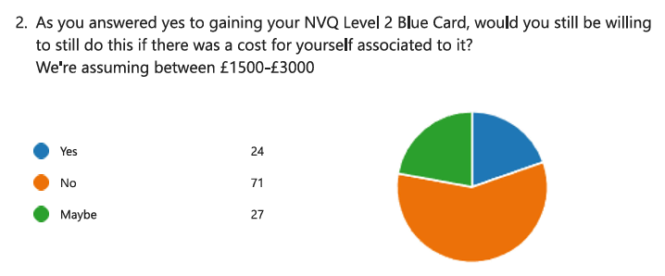
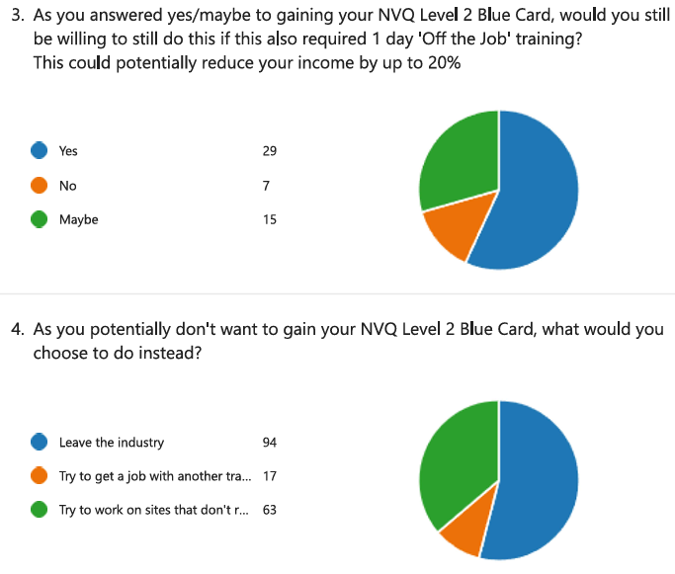
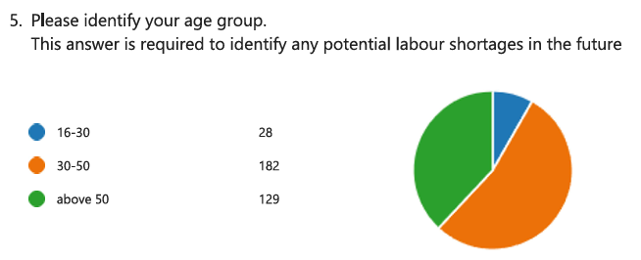

10 Dates of next meeting

MD/CY were asked to look at timings to give a further 30 mins to the Executive.

Meeting Dates for 2024 are as follows:

Date | Venue
Tuesday 2nd July | Manchester Hall (36 Bridge Street, Manchester
Thursday 26th September | FETA
Thursday 5th December | VSC plus an early evening dinner

The Science and Industry Museum in Manchester was NOT available as it is undergoing a major refurbishment.

Claire Watson and Elizabeth at FETA have found Manchester Hall (36 Bridge Street, Manchester) and they are able to accommodate the ADCAS meeting – it was one of Claire’s recommendations and looks lovely. The date also has to be changed and will be Tuesday 2nd July.

They do not have speakers for the AV (but do have screen and cables) but FETA would be able to take the portable speakers – and their technician would be happy to help set up prior to the meeting. There is a minimum number of 30.

Their website says: “The perfect conference venue in Manchester. We have 13 unique and different sized conference meeting rooms. Our venue is versatile to meet your business needs. From large conferences to smaller corporate events. Our dedicated team are also on hand to ensure your business event runs efficiently”.

“Placeholder” invitations have been issued so members can get the dates in their calendars for the whole year.

Members should check the notice/agenda for the meeting which will be circulated three weeks before the meeting as dates/venue/format may change.

Chair …………………………………………………… Date ……………………………

(for approval at next meeting)

Annex A Marketing Working Group Update
Website actions

No. | Action agreed | Resp. | By when? | Done?
1. | C/F - It was agreed that a filter on members so specialisms could be selected e.g. fire rated ductwork, manufacturer etc so it becomes a more useful member directory. CY to draft up an Excel spreadsheet covering all members to be agreed by the group and then enable Jason to do the upgrade. Categories agreed as:  - Fabricators, components, Manufacturer, Installer, other  - Ductwork  - Fire rated, rectangular, circular, flex  - Do we add type of work they undertake? Discuss  - Smoke control, fire rated, specialist.  - Training provided | CY | October 23
2. | Resources pages (6) to be reviewed to decide if it is relevant and are there any additions? Technical committee best placed. To be discussed with Darren Webster. | CY | 4/10/23
3. | Website upgrades to be quoted for by Jason:  - Link case studies to a member profile so they make the link rather than ADCAS/FETA (2 or 3 maximum).  - Sort website alphabetically and sorted using Excel spreadsheet above.  - Member profile to include:  - Company info, contact, case study(s), social media, logo  - Individual micro site?  - Brief Jason and then organise a 30-minute Teams call with the Marketing Group  - Training page to be set up and include details of training done by members.  - ADCAS Constitution needs to open in a new page and not go off the website.  - Jobs section – meeting does not think we need this. Members could add a link to their own profile.  - Adobe stock images to be used for new photographs.  - Members to be able to add photos to their profiles.  - Form to be filled in for members to create their own profile rather than FETA doing it for them.  - MC to have access to the website to upload news. | CY  CY  MC  CY | October 23  October 23  October 23  October 23 | Email sent.

ADCAS Social Media Report

LinkedIn

Followers

03 January 630
01 February 652
01 March 681

Engagement rate 6.3%

Engagement rate for October to December 2023 was 4.2 so this is a notable increase.

Twitter

Followers

03 January 49
01 February 50
01 March 52

Engagement Rate 5.5%

Popular themes

- Q&A with Paul Williams, Domus Ventilation
- ADCAS member B&R Installations Ltd
- ADCAS membership benefits

